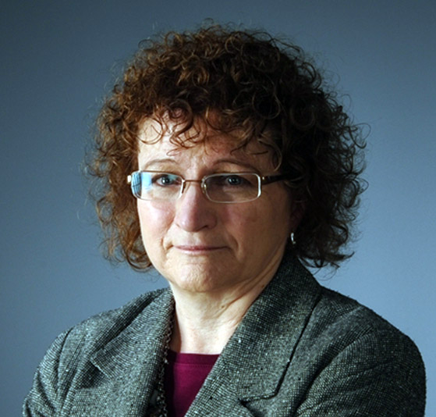
Your Local CPCU Chapter is Going YEAR ROUND!
By Jane D’oh, CPCU, CIC, CRM
In the past, this time of year would bring us to preparations for our annual local membership meeting in April along with the chapter board member elections. This was always followed by installation in May with chapter activities suspended for the summer. As the CPCU Society is converting to calendar year, it provides a great opportunity to adjust our local chapter event schedule and provide more value to our members.
Here is a snapshot of plans for the summer and beyond:
- A social is being planned for June to kick the summer off; location yet to be determined
- A breakfast meeting in July will bring the opportunity for 3 CE hours, location yet to be determined
- A regular monthly luncheon meeting will be held in August
- The new designee reception will be held in September in addition to our regular monthly meeting
- The annual local membership meeting and elections will be conducted at the October monthly luncheon
- Planning another 3 hour CE opportunity for October
- Board Member Installation will take place at I-Day November 15th
- Another social in December will close our year
In addition to everything above, we are working on creating a Northern Sub-Chapter of our Colorado CPCU Society Chapter. We recognize there are numerous CPCUs located in Northern Colorado and Wyoming that aren't able to realize the full value our local Chapter brings. We are currently working with the Society to determine the next steps to take to create a sub-chapter. Soon we will be reaching out to interested members to help form the foundation of the Northern Sub-Chapter. If you are interested in being a key part of the sub-chapter creation please contact me at email@email.com or the President-Elect Kylie Unger at notemail@email.com.
It is shaping up to be a great year!! Don't forget to renew your membership, so you can participate throughout the year at our member discounted rate. Obtaining your CPCU designation is just the first step on a life long journey of learning. Being a member of the CPCU Society demonstrates your commitment to maintaining and growing your knowledge in the Insurance Industry. You expended significant time and effort earning your CPCU designation; don't let all of that hard work go by the wayside. Take advantage of what your CPCU Society Membership gets you!
Membership isn't simply about having time TODAY to volunteer or attend local monthly chapter meetings; you have earned the right to this membership. Membership assures that you have access to information to remain current in your career. Additionally, the Society and our local chapter continue to expand on 'value added' member only options. The CE and educational opportunities alone make your membership worth it. Demonstrate your commitment to lifelong learning through your membership in the CPCU Society and your Local Chapter.
I look forward to seeing you in the coming months.

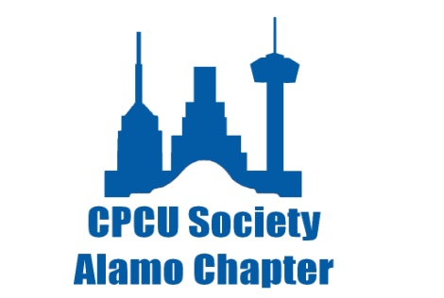
Chapter Member Spotlight
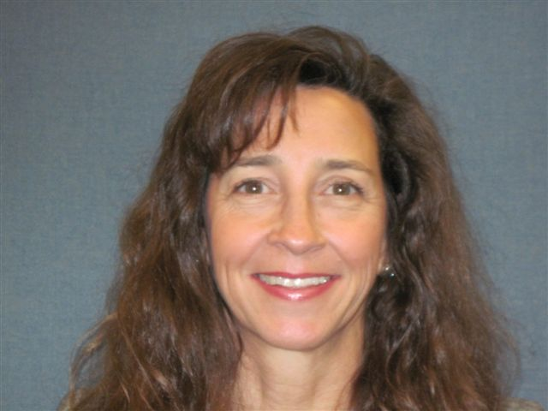Jane D’oh
Answer each of the questions in a paragraph format, suitable for publication:
- How long have you been in the insurance industry?
I have been in the insurance industry for 36 years. I began my insurance career with Commercial Union where I was employed for 2 years while also attending night school. I then gained employment with State Farm Insurance Companies and continued attending night school to earn a degree in Finance.

- Please describe the path that you took and the amount of time it took you in pursuit of your CPCU designation?
After so many years of night school to earn my Bachelor’s degree while working full time, it was a natural progression to continue my education. Since my employer strongly supports continuing insurance education, I pursued the CPCU designation and completed it in 1995.

- Do you have any advice to share with someone thinking of getting the designation?
Whether you do it the slow and methodical way, or fast and furious, “just do it”. It will open doors that you can’t even see right now. It will prepare you for the future. It will get that foot in the door. It will round out your knowledge. It will give you that little extra edge against another candidate for a promotion. It will introduce you to new people, perspectives, ideas, and networking. So many reasons…., so little time. Don’t put it off. Do it now.

- Tell us something about yourself that none of us know.
Hmmmm……..Some of you know I am an avid water skier. I was considering becoming a BSA (Boy Scouts of America) lifeguard so that my son’s troop can do more campouts involving swimming and boating, so I thought I would go to a pool & see if I could swim the 550 yards that is required even though I am not an avid swimmer. Before I knew it, I swam 2/3 of a mile in about 40 minutes. The next day, I swam a mile in less than an hour (which is about 3 times the distance than what is required for the lifeguard certification). Not very smart. It took me almost a week to recover. I’m still considering.
About the CPCU Society and the Bayou Chapter
The Chartered Property Casualty Underwriters (CPCU) Society is a community of credentialed property and casualty insurance professionals who promote excellence through ethical behavior and continuing education.
The Society's nearly 28,000 members hold the Chartered Property Casualty Underwriter (CPCU) designation, which requires passing rigorous undergraduate- and graduate-level examinations, meeting experience requirements, and agreeing to be bound by a strict code of professional ethics.
Founded in 1944, the CPCU Society's mission is to "meet the career development needs of a diverse membership of professionals who have earned the CPCU designation, so that they may serve others in a competent and ethical manner."
The CPCU Society offers tremendous opportunities that will help you propel your career to new heights. It also works hard to spread the message about the value of the CPCU designation to the industry and the public.
The Bayou Chapter of Chartered Property Casualty Underwriters was founded over 30 years ago to serve the needs of members in the Baton Rouge area, as well as points west to Lafayette and Lake Charles. The Bayou Chapter strives to provide educational opportunities to the membership (as well as the insurance industry as a whole) through monthly meetings (9 meetings per year) and the annual I-Day. The Chapter also regularly makes available study group sessions for those preparing for various designations available through the American Institute for Chartered Property Casualty Underwriters (see the Education section of this website). The Bayou Chapter also contributes to the community through various civic activities. To become a member of the Bayou Chapter, please contact any of the officers and chairpersons for additional information.
What it means to be a CPCU…
A “CPCU” or Chartered Property Casualty Underwriter,
is an insurance professional who has earned the CPCU designation. CPCUs are considered the standard setters of the insurance industry. In order to achieve this prestigious designation, insurance professionals must meet certain requirements in the following areas:
Education
CPCUs pass national exams on topics including insurance law, accounting, risk management, and ethics. CPCUs continually update their base of insurance expertise by participating in technical and professional development workshops and seminars.
Ethics
CPCUs promise to abide by a Code of Professional Ethics, placing their clients’ needs before their own.
CPCU Canons, Rules, and Guidelines of the Code of Professional Ethics
Experience
CPCUs meet an experience requirement to become a CPCU and have proven insurance expertise and knowledge.
For more information on becoming a CPCU, visit the American Institute for CPCU’s web site.

CENTRAL VIRGINIA CPCU SOCIETY CHAPTER
WELCOMES NEW MEMBERS

Charlottesville, Virginia, September 14, 2012 — The Central Virginia CPCU Society Chapter recently welcomed four new members to its chapter. The designation was formally confirmed at a ceremony in Washington, DC on Saturday September 08, 2012. The conferment was held in conjunction with the 68th CPCU Society Annual Meeting and Seminars.

- Laura Ellis CPCU
- Lori Watson CPCU
- Ryan Murphy CPCU
- Shane Powers CPCU

The designees were also recognized at a Central Virginia Society Luncheon on Friday, September 14, 2012 held at local restaurant on the Charlottesville Downtown Mall. The new members were acknowledged for their educational accomplishment to the Insurance Industry and for their commitment to the highest level of professional and ethical behavior.

Members of the Central Virginia CPCU Society Chapter are involved in a number of educational, charitable and volunteer events throughout the year, including Educational Fairs, Adopt a Family, and Habitat for Humanity. For more information on the Central Virginia CPCU Society Chapter, visit: http://centralvirginia.cpcusociety.org, or contact George Norko (chapter secretary) at 434-872-6054 or email: probablyemail@email.com.

About the CPCU Society
The CPCU Society is a community of credentialed insurance professionals who promote excellence through ethical behavior and continuing education. The Society's more than 25,000 members hold the Chartered Property Casualty Underwriter (CPCU®) designation, which requires passing eight rigorous undergraduate- and graduate- level examinations, meeting experience requirements, and agreeing to be bound by a strict code of professional ethics. The CPCU designation is conferred by The Institutes. More information about the CPCU Society is available at www.cpcusociety.org.

Human Resources Publication

An Employers Nightmare…the Wage and Hour Issue

By Jeffrey Cavignac, CPCU, ARM, RPLU, CRIS

President—Cavignac & Associates

Sandee Rugg, SPHR–CA

Director of Human Resources—Cavignac & Associates
It will come as no surprise that the poor economy, which has resulted in massive lay-offs and terminations, has caused employment related claims and lawsuits in general to increase. Wage and hour litigation seems to be increasing the fastest. The Department of Labor estimates that wage and hour complaints increased 15% from 2009 to 2010. That is not surprising when you consider the complexity of the laws applying to who is exempt and who isn't, and how to calculate overtime for those employees who are non-exempt. Even the most diligent employer has difficulty sorting through the morass of rules and regulations, let alone enforcing them.* Another reason for the growth of wage and hour claims is the ease with which one may establish a class action suit under the Fair Labor Standards Act (FLSA). While not everyone may be harassed or discriminated against, everyone gets a paycheck and may be easily incorporated into a group. Attorneys don't need to consult an "expert", and class action status can usually be certified pretty quickly. In addition, unlike a harassment or discrimination law suit that must first be presented to the Equal Employment Opportunity Commission, a plaintiff attorney can go straight to litigation when working on a wage and hour issue.

2013 CPCU San Diego Chapter News
Survey Results
Our survey results for the 2012 June Installation Meeting are in, and the feedback is very positive! On a scale of 1-5, with 5 ranked as “best,” we scored an average of 4.7!
We welcome your feedback. After all, this is your Chapter! Many of you commented that you enjoyed the venue. The Bahiaalways seems to provide a quick mental get-away and a nice break from the stresses back at the office!
Several of you noted that you felt the food was excellent and that you’re looking forward to attending future networking meetings.
Please contact us any time you have suggestions or comments. And if you enjoy planning, join us at our next Board meeting. We can always put your talents to work!

I-Day, Septemberber 8, 2013

I-Day was held at the Seattle Red Lion in a new format. We had a seminar that was a Mock Mediation, led by Dale Kingman. A Vendor Fair and Reception followed with the Conferment presided over by Cass Cossairt, Governor for the Western Region. Nine of our 21 new designees were able to be inducted into the CPCU Pacific Northwest Chapter. In addition, Cass presented President, Darla Lane, with the Gold Circle of Excellence Award for the chapter for the past year.
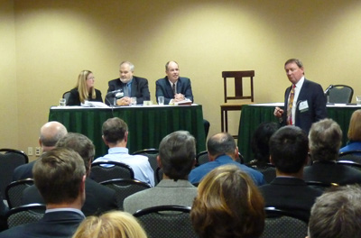
I-Day Panel of defendants with mediator Dale Kingman..
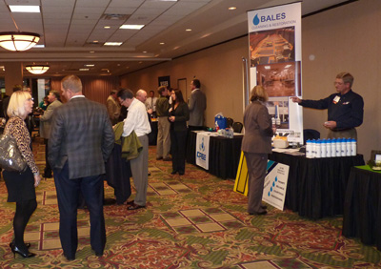
Vendor Fair
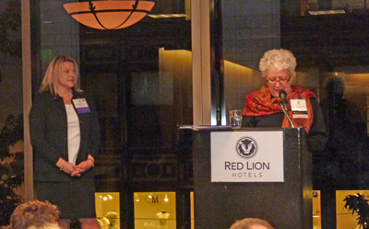
Darla Lane accepts the Circle of Excellence Gold Award.
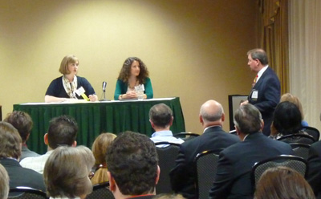
I-Day Panel of plaintiffs.
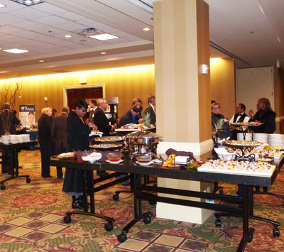
Light buffet and bar.
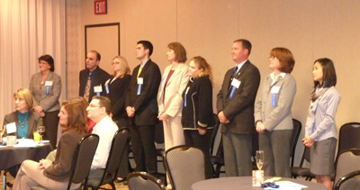
New Inductees before conferment.

Congratulations New Designees
Bob Hood and Christina Stillwell recently completed the CPCU program and will be traveling to Nashville TN for the Annual Meetings and Seminar.
Christina Stillwell graduated from Strayer University with a Bachelor in Business Administration in December 2005. She is currently pursuing her Masters in Education Management.
She has been in insurance since December 1999, all of that time with GEICO. She began her GEICO career in auto and motorcycle sales, moved to the training department and is currently a supervisor managing many responsibilities.
Her time outside of work is spent with her 12 year old son, Jordan. Her parents, Billy and Shelia, as well as her brother Rob, are all in the area. Christina and her son do animal rescue work and have a variety of pets including: 2 Great Danes, a Bassett Hound, a Lab/Greyhound mix, 3 turtles, 4 Geckos, 2 snakes, 1 frog, 3 ferrets, and an assortment of fish.

Bob Hood graduated from Longwood College in 1990 with his Bachelors Degree in Business Administration.
He has worked in insurance for 14.5 yrs. In his insurance career with GEICO, he has been a sales agent, customer service agent, new business underwriter, customer service supervisor, sales supervisor and underwriting supervisor.
Bob is happily married and has 4 children, 3 dogs & a cat.
He enjoys playing sports, watching sports, spending time with his family, traveling and music.
Bob is currently teaching CPCU courses and is the Chairman of Education for the Tidewater chapter in his spare time.

PRESIDENTS CORNER
I am honored to begin my service as the Tidewater Chapter President for 2006-2007. We have just ended a great year under the leadership of outgoing President Margarita Hudgins. Our Chapter earned the Gold level award for the past year and Margarita will proudly accept that on our behalf at the National Society Annual Meeting and Seminars held in Nashville TN September 9-12, 2006.

Your board has been busy this summer pulling together some great ideas for the coming year. One of the suggestions over the years has been to increase membership attendance at events. We thought that one way to make it easy for our membership to schedule meetings would be to hold a regular monthly meeting. We have selected the 3rd Thursday of every month (with the exception of November) as our standard meeting day. We will have an opportunity to vary the type and time of the meeting each month. We have two events in November (Steinhilber’s and ODU Founder’s Day) that will be outside of this format but you can go ahead and block the 3rd Thursday of every month for a CPCU event. We hope to offer a variety of programs that will be fun, informative and help in your professional development.
We will kick off the year with an event at Hot Tuna Bar and Grill on Shore Drive at 5:30pm on Thursday September 21st. We have arranged for a guest speaker to discuss the challenges of Risk management with the Jamestown 2007 project. Look for details in the September Chaptergram or check out the website page for a list of events. We will be updating this regularly so save the site to your favorites and visit it often. http://tidewater.cpcusociety.org
Your board is anxious for your input. We would love to hear your ideas on how we can make this another outstanding year. Please feel free to contact me at nope@email.com to share your thoughts. I am looking forward to seeing everyone soon.
Jane D’oh

ANNUAL TIDEWATER CHAPTER PICNIC
On September 15, 2013, the Tidewater Chapter annual picnic was held at USAA.
We would like to thank all the CPCU members, candidate members, and students pursuing the CPCU designation who joined us in honoring our new designees.
The $100 Education Grant was awarded to one of our candidate members, Leslie Lewis from USAA.
Pictured below with Margarita Hudgins, Chapter President are some of our newest designees: (L to R) Kevin Todd, USAA; Margarita Hudgins, USAA; Aaron Bloom, GEICO; Amanda White, USAA.
